EVERYBODY RIDES THE CAROUSEL
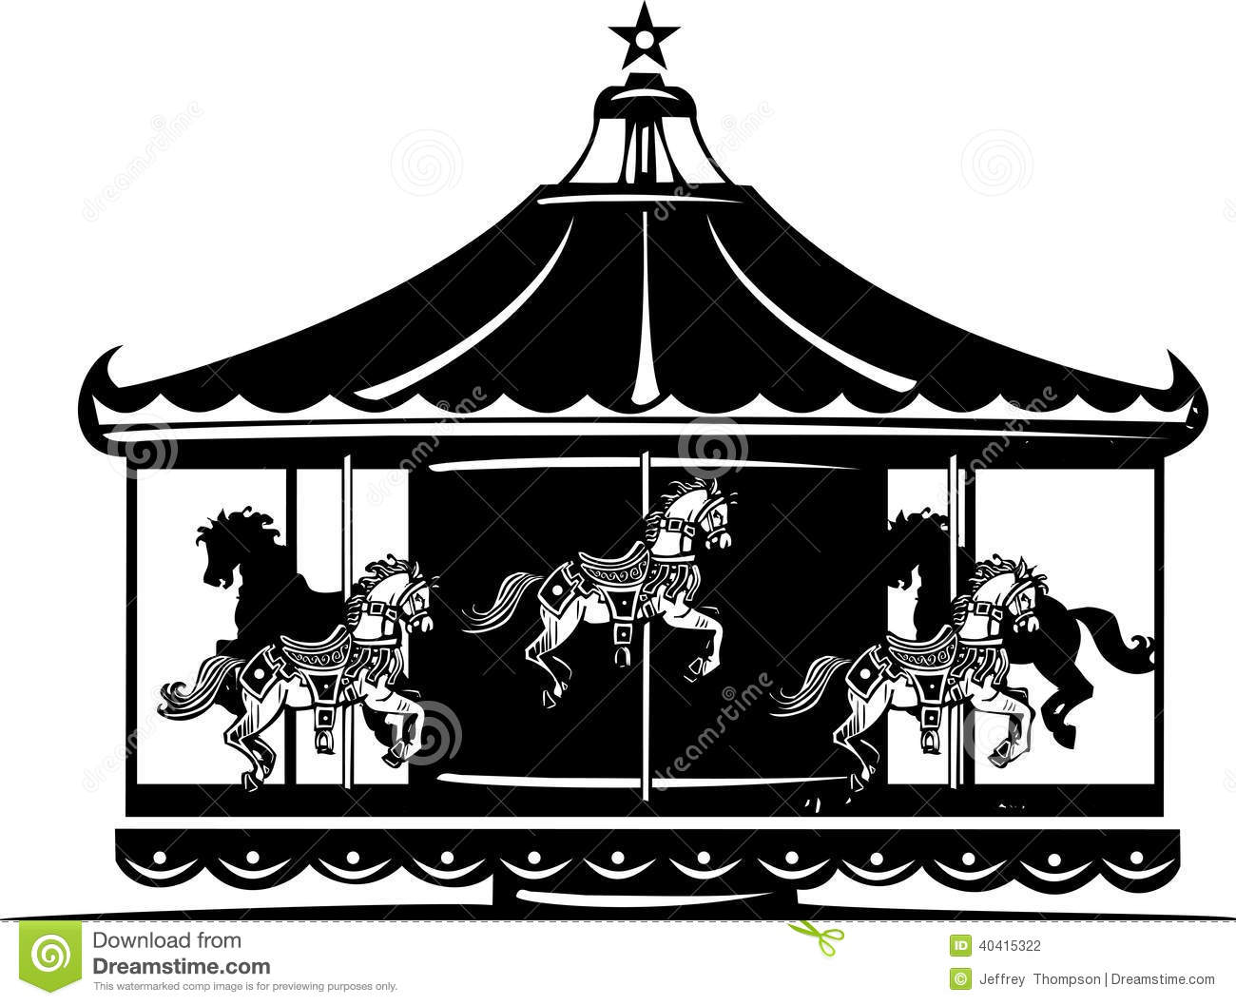
IDENTITY vs ROLE CONFUSION & INTIMACY vs ISOLATION

While watching the video Everyone Rides the Carousel use the facilitation questions below to clarify your thoughts on Erikson’s theory.

Stage 5: Identity vs Role Confusion -The Realization of One’s true self

1. Why is the setting of an amusement park appropriate for this particular stage?

2. What does the following imagery represent?

a) the roller coaster

b) moving file cabinets

c) “mirror of tomorrow”

d) many doors

e) family dinner

f) child on the bicycle

Stage 6: Intimacy vs. Isolation - Learning how to share oneself with others

3. What does the following imagery represent?

a) the dark “inner faces”

b) the masks

4. Why does the couple pull on their masks?

5. How was the story of the interaction of the couple different the second time?

6. How might you better learn to share yourself with others?

7. What are the consequences of not learning to do so?

Psychology and Religion
January 2013
Dr. King
Erik Erikson’s 8 Stages of Psychosocial Development Theory via Everyone Rides the Carousel video
Directions: While watching the video Everyone Rides the Carousel use the facilitation questions below to clarify your thoughts on Erikson’s theory. When the video is done, use DeBono’s Six Thinking Hats worksheet to further reflect on the video as a whole and clarify his 8 stages of development.
Stage One: Trust vs Mistrust: The Ride of the Newborn
How effective was the imagery of this section? What new insights were provided?

Stage Two: Autonomy vs Shame and Doubt: Working on a Sense of Autonomy
What was the significance of the lion and the rabbit? Insights?

Stage Three: Initiative vs Guilt: Trying on Parents Clothes
What positives and negative, if any, do you have?

Do you see any hints of Freud’s influence? What Freudian theory is represented?

Significance of rabbit showing up again?

Stage 4: Competence vs Inferiority: Learning to do things well
What are some long term impacts to the personality related to challenges of learning things well?

Stage 5: Identity vs Role Confusion: Realization of One’s true self
Why is the setting of an amusement park appropriate for this particular stage?

What might the ‘Mirror of Tomorrow’ represent?

Stage 6: Intimacy vs. Isolation: Learning how to share one’s self with others
How might you better learn to share yourself with others?

What are the consequences of not learning to do so?

What was different the second time? What happened that didn’t happen before?

Stage 7: Generativity vs Stagnation: Caring for the Next Generation
Possible examples of each?
Consequences of not caring? Significance of fishes?
What are some challenges of balancing work/career with family? How would you describe the husband’s reaction?

Integrity vs Despair: Age of Wisdom and developing a Sense of Irony and laughter in face of Death
What is actually going on between the couple in the café line?

How does the couple giving candy out at Halloween illustrate the challenges of this final stage?

